Setup Document

Fontys ICT

English stream

**ProP**

**Group : ProP-17**

**Date :**

**Version : 0.4**

**TABLE OF CONTENTS**

Agreements - made with the client 3

Processes 4

Use cases website 4

Use cases for applications 7

Functional requirements 11

Website 11

Applications 11

Graphical user interface 12

Entrance application: 12

Camping application: 13

Shop application: 14

Loan stand application 15

Exit application 16

Status application 17

Convert application 17

Website wireframe 18

Entity relationship diagram 25

# Agreements - made with the client

# Processes

## Use cases website

**Name:** Purchase a ticket

**Brief Description:** The user purchases a ticket on the website by providing their information. The provided information is then verified and if it is valid the user receives an email with the ticket and its information.

**Actors:**

The user is the visitor of the website.

The system is a website.

**Basic Flow:**

1. User opens website
2. User goes to the buy ticket page
3. System asks for name, surname, email, password and bank account number
4. The user provides their name, surname, email, password and bank account number
5. System requires confirmation
6. User provides confirmation
7. The system verifies that the user’s email, password, and bank account number are valid
8. System complete the transaction
9. The system sends an email to the user’s email with the ticket

**Exceptions:**

7.a One or more of the following items that the user provide is not valid: email password and bank account. The use case end.

**Name:** Log in

**Brief Description:** A user with an “event” account logs in to there account on the website by providing their password and ticket number these are verified by the website. If the password and ticket number are valid the user gains access to their account

**Actors:**

The user is an “event” account owner.

The system is a website.

**Preconditions:** User purchased a ticket and knows ticket number and password

**Basic Flow**:

1. User Opens the system
2. User goes to login page
3. The system asks for the password and ticket number
4. The user provides their ticket number and password
5. System requires confirmation
6. User provides confirmation
7. The system verifies that the user's ticket number and password is valid
8. The system gives the user access to their account

**Exceptions:**

7.a The ticket number and or password that the user provided is not valid. The use case ends.

**Name:** Add credits to account

**Brief Description:** User logs in to account and adds credits to their account by providing there bank account details to the website which validates bank account and collect the selected amount. The credits are then added to the user's account.

**Actors:**

The user is an “event” account owner.

The system is a website.

**Preconditions:** User is logged in

**Basic Flow:**

1. User goes to the profile page
2. The user selects add credits
3. System ask for an amount and bank account number
4. The user provides an amount and bank account number
5. The system verifies the user's bank account number
6. The system waits to receive the correct amount from the user's bank account
7. The system adds credits to the user's account

**Exceptions:**

5.a The bank account number and or password that the user provided is not valid. The use case ends.

6.a There was not enough funds to complete the transaction. The use case ends.

**Name:** Reserve camping

**Brief Description:** User logs in to account and reserves a camping spot by selecting the spot and specifying the other participants. The user has the option to pay immediately or later.

**Actors:**

The user is an “event” account owner.

The system is a website.

**Preconditions:** User is logged in

**Basic Flow:**

1. User goes to the profile page
2. The user selects reserve camping spot
3. The system asks the user to select a camping spot and amount of participants
4. The user selects a camping spot and provides the number of participants
5. The system provides the options to pay now or later
6. User selects pay now
7. System reserves camping spot

**Alternate flow:**

6.a User selects pay later

**Name:** Leave a review

**Brief Description:** User logs in to account and leaves a review of the event.

**Actors:**

The user is an “event” account owner.

The system is a website.

**Preconditions:** User is logged in

**Basic Flow:**

1. User goes to review page
2. The user selects to add a review
3. System ask for the review
4. The user provides their review
5. System submits the user's review

## Use cases for applications

**Log in application**

**Name:** Log into application

**Brief Description:**

**Actors:**

The user is an event worker that works at the event

The system is the log in application.

**Basic Flow:**

1. The system waits for a employee number and password
2. User provides employee number and password
3. The system verifies the employee number and password
4. The system displays the different applications that the user can choose from
5. The user chooses application

**Exceptions:**

3.a The employee number or password that the user provided is not valid. The system displays that they are not valid. The use case ends

**Entrance application**

**Name:** Scan ticket

**Brief Description:** The user scans the ticket barcode and the system determines if the barcode is valid. The system displays whether the barcode is valid or not

**Actors:**

The user is an event worker that works at the entrance of the event

The system is the entrance application.

**Basic Flow:**

1. The system waits for a barcode to be scanned
2. User scans barcode
3. The system verifies if barcode belongs to a valid ticket that has not already scanned
4. System displays that the ticket is valid

**Exceptions:**

3.a The barcode does not belong to a valid ticket or the ticket has already been scanned. The System displays that the ticket is not valid. The use case ends.

**Name:** Buy a ticket

**Brief Description:** User provides email to the system. The system then generates a secure password and send the password along with the purchased ticket number to the provided email.

**Actors:**

The user is an event worker that works at the entrance of the event

The system is the entrance application.

**Basic Flow:**

1. The user provides the email of the person buying a ticket
2. The system verifies that the provided email is valid
3. The system generates a secure password and sends the password with the number of the purchased ticket to the provided email
4. The system provides confirmation that purchasing the ticket was a success

**Exceptions:**

2.a The email that was provided by the user was not a valid email address. The use case ends.

**Name:** Program RFID chip

**Brief Description:** The system programs the “event” account of the scanned or bought ticket to the RFID chip.

**Actors:**

The user is an event worker that works at the entrance of the event

The system is the entrance application.

**Preconditions:** A ticket has been scanned or a ticket was just bought

**Basic Flow:**

1. The user selects program chip
2. System programs a unique code linked to the ticket that was scanned or bought
3. The system gives confirmation that the chip was programmed successfully

**Alternate flow:**

3.a The system says that the chip programming was unsuccessful.

**Entrance at camping application**

**Name:** Check if group paid

**Brief Description:** The user provides the “event” account the system then checks if the camping spot still needs to be paid for and if so calculate and display the to be paid amount.

**Actors:**

The user is an event worker that works at the entrance of the camping spots

The system is the camping application.

**Basic Flow:**

1. The user provides the visitors RFID chip
2. The system reads the provided RFID chip
3. The system verifies that the provided “event” account has reserved a camping spot
4. The system verifies that the camping spot still needs to be paid for
5. The system calculates the amount needed to be paid
6. The system displays the amount that needs to be paid

**Alternate flow:**

4.a The camping spot has already been paid for. The system displays that it has already been paid for. The use case ends.

**Shop application**

**Name:** Buy item

**Brief Description:** The user selects item(s) the system then calculates the total price. The user then provides an “event” account the system then checks if there is enough funds to purchase the selected items and if so lower the credits by that amount.

**Actors:**

The user is an event worker that works the shops at the event

The system is the shop application.

**Basic Flow:**

1. The user selects the item(s) that the visitor requested
2. The system calculates and displays the total price of the item(s)
3. The user provides the visitors RFID chip
4. The system reads the provided RFID chip
5. The system verifies that the provided “event” account has enough event credits to purchase the item(s)
6. The system lowers the credits of the provided “event” account by the total price of the items
7. The system generates and provides a receipt

**Exceptions:**

5.a The “event” account does not have enough credits to pay for items. The system displays that there are not enough funds to complete the transaction. The use case ends.

**Loan stand application**

**Name:** Loan items

**Brief Description:** The user selects an item(s) the system then calculates the total price. The user then provides an “event” account. The system then checks if there are enough funds to loan the selected items and if so lower the credits by that amount and put the loaned items on the provided “event” account.

**Actors:**

The user is an event worker that works at the loan stand at the event

The system is the loan stand application.

**Basic Flow:**

1. The user selects the item(s) that the visitor requested
2. The system calculates and displays the total price of the item(s)
3. The user provides the visitors RFID chip
4. The system reads the provided RFID chip
5. The system verifies that the provided “event” account has enough event credits to loan item(s)
6. The system lowers the credits of the provided “event” account by the total price of the loaned item(s)
7. The system adds loaned items to “event” account
8. The system generates and provides a receipt

**Exceptions:**

5.a The “event” account does not have enough credits to pay for items. System displays that there are not enough funds to complete the transaction. The use case ends.

**Name:** Return loaned items

**Brief Description:** The user provides an “event” account. The system then checks if there are any loaned items on the account and if so displays the items

**Actors:**

The user is an event worker that works at the loan stand at the event

The system is the loan stand application.

**Preconditions:** Visitor has loaned items

**Basic Flow:**

1. The user provides the visitors RFID chip
2. The system reads the provided RFID chip
3. The system displays all of the items loaned by the provided “event” account
4. User collects items
5. The system marks the items on the provided “event” account as returned

**Exiting application**

**Name:** Leave event

**Brief Description:** The user provides an “event” account. The system then checks if there are any loaned items on the account if there are it displays the items. It also checks there is still credits on the account and if there are it displays the amount that needs to be returned. The provided account is then marked invalid.

**Actors:**

The user is an event worker that works at the exit of the event

The system is the exit application.

**Preconditions:** Visitor has entered the event

**Basic Flow:**

1. The user provides the visitors RFID chip
2. The system reads the provided RFID chip
3. The system checks the balance of the provided “event” account
4. The system displays the amount to be returned
5. The system verifies that there are no loaned items on the provided “event” account
6. The system marks the provided “event” account as invalid

**Alternate flow:**

5.a There are loaned items on the provided “event” account. The system displays the loaned items.

**Status application**

**Name:** Update status

**Brief Description:** The user request to update the status of the application. The system then retrieves the data from the database and displays the updated status.

**Actors:**

The user is an event worker

The system is the status application.

**Basic Flow:**

1. The user selects show info
2. The system displays the update data it retrieves from the database

**Convert transaction-log-file application**

**Name:** Convert

**Brief Description:** The user provides a transaction-log-file. The system then extracts the information from the file and updates the database.

**Actors:**

The user is an event worker

The system is the transaction-log-file converter application.

**Preconditions:** Visitor has entered the event

**Basic Flow:**

1. User provides transaction-log-file
2. The system verifies the provided file is valid
3. The system transfers the information from the text file to the database
4. System displays that the information was transferred successfully

**Alternate flow:**

4.a The system displays that the information transfer was unsuccessful

# Functional requirements

## Website

Must:

* Allow people to buy tickets to the event
* Allow account owners to reserve camping
* Allow account owners to add credits to their account

Should:

* Display information about the event
* Display contact information

Could:

* Display the answers to frequently asked questions
* Allow account owners to leave a review of the event
* Display the events review

## Applications

Must:

* Show if the scanned ticket is a valid ticket
* Create a new “event” account with the provided email
* Program RFID chip
* Read RFID chip
* Lower the credits of the provided “event” account by the total price of the items
* Check if “event” account has reserved a camping spot and if it's paid for
* Calculate the to be paid amount for the camping spot
* Lower the credits of the provided “event” account by the total price of the loaned items and adds loaned items to “event” account
* Mark the item(s) on the provided “event” account as returned
* Check that there are no loaned items on the provided “event” account
* Show the amount of money that needs to be returned when exiting event
* Mark the provided “event” account as invalid when exiting event
* Show status of the event
* Convert the information in transaction-log-file to database
* Generate receipt

Should:

* Login user to get access to the applications they are allowed to applications

# Graphical user interface

The light grey text boxes are read-only.

The white text boxes are read and type.

The white box with a cross is a picture box.

## Entrance application:

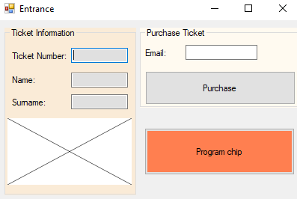

The picture box first show waiting then when a code is scanned the ticket number, name, and surname text boxes are filled in if the code is valid. If not it displays that the code is not valid in the picture box. The user fills in the email text box and clicks purchase. A ticket is then purchased with that email. When the program chip button is pressed the RFID chip is then programmed.

## Camping application:

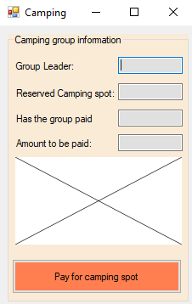

The picture box shows waiting until an RFID chip is scanned. When a chip is scanned the above text boxes are filled if the “event” account reserved a camping spot if not the picture box displays that there is no reservation on that account. When the pay for camping spot button is pressed the database is updated.

## Shop application:

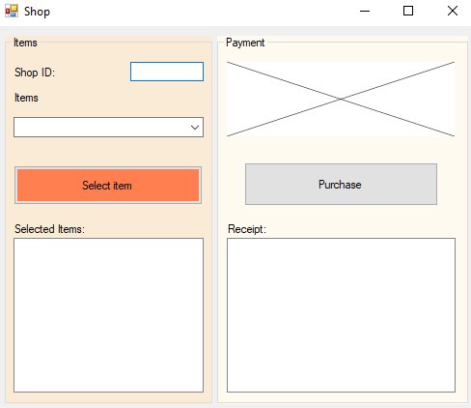

The user fills in the ID of their shop in the text box. The user uses a combo box to pick an item and presses the select item button to select it. The selected items are displayed in the list box. The picture shows waiting until an RFID chip is read, the user can then press the purchase button to complete the transaction. The receipt of the transaction is then shown in a list box.

## Loan stand application

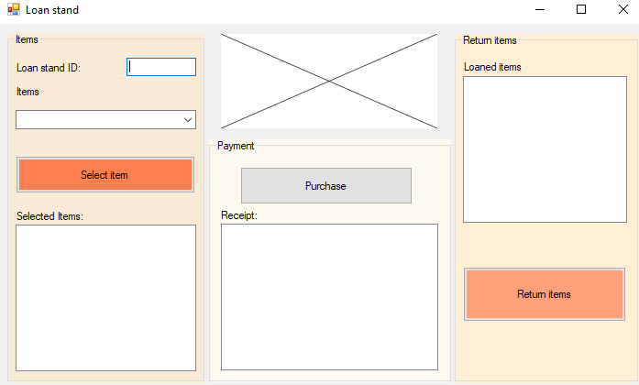

The user fills in the ID of their Loan stand in the text box. The user uses a combo box to pick an item and presses the select item button to select it. The selected items are displayed in the list box. The picture shows waiting until an RFID chip is read, the user can then press the purchase button to complete the transaction. The receipt of the transaction is then shown in a list box. When the RFID chip is read the return items list box then displays all items currently loaned by that visitor. The user selects the items to return and then presses the return items button to return the items.

## Exit application

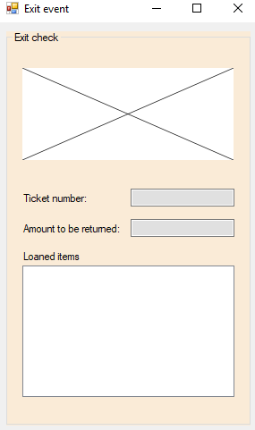

The picture box shows waiting until an RFID chip is scanned. The ticket number, amount to be returned are displayed in text boxes and the loaned items are shown in a list box.

## Status application

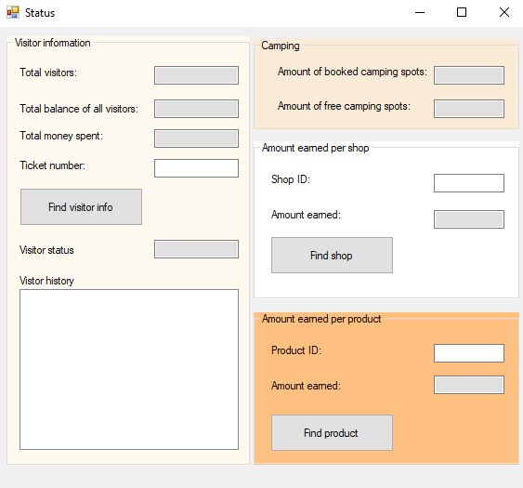

The application retrieves the data from the database and fills in the text boxes and list boxes. For the specific information such as the amount earned per product, an ID is filled into the text boxes and when the button is pressed it finds the data and displays it in a list box or text box.

## Convert application

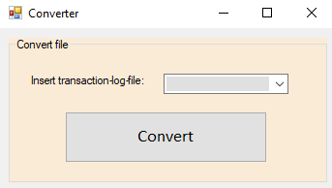

The user provides a transaction log file and presses the convert button to convert the file.

# Website wireframe

**Home page**

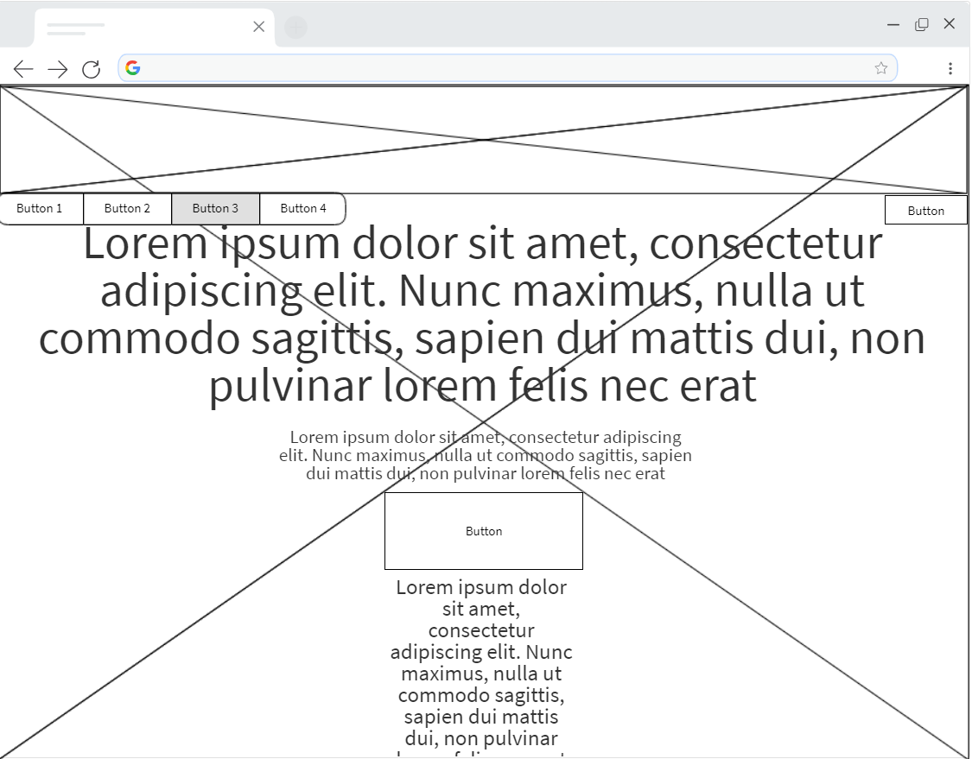

**About us page**

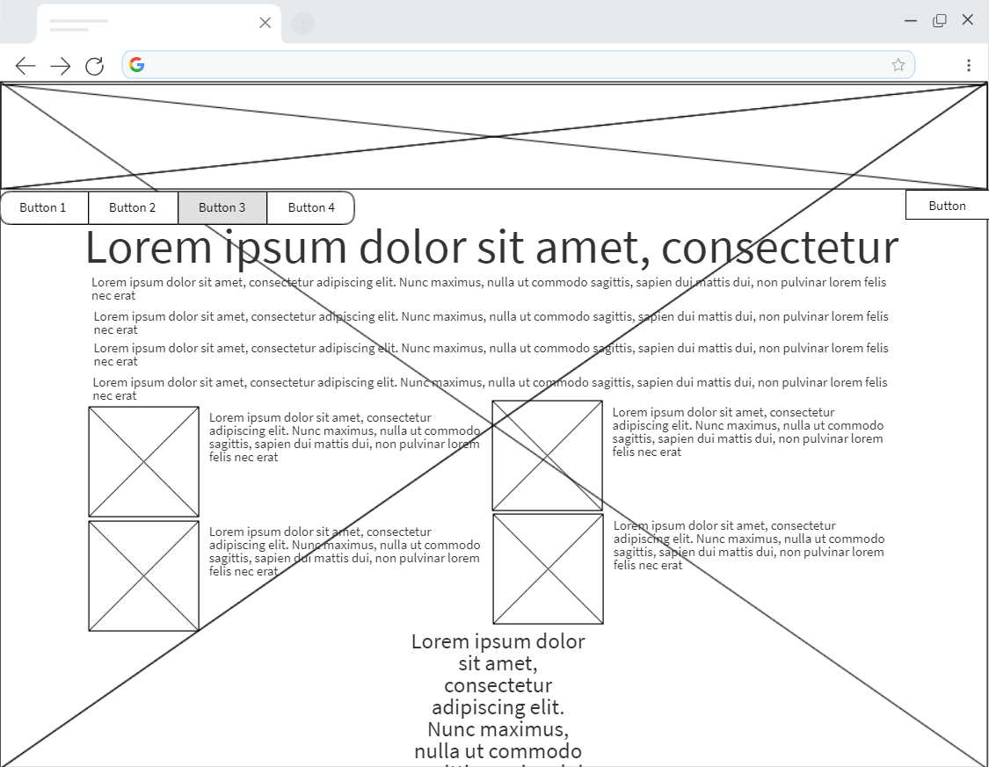

**Buy a ticket page**

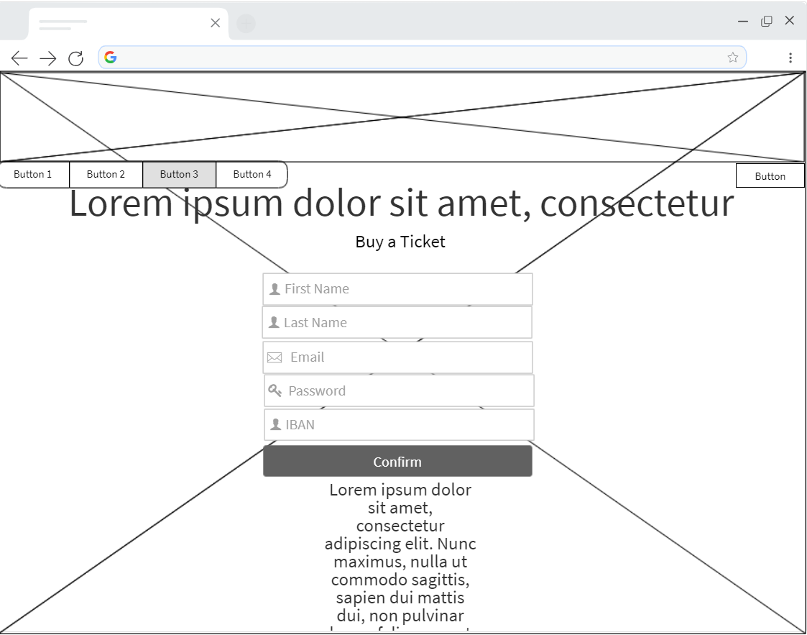

**Contact us wireframe page**

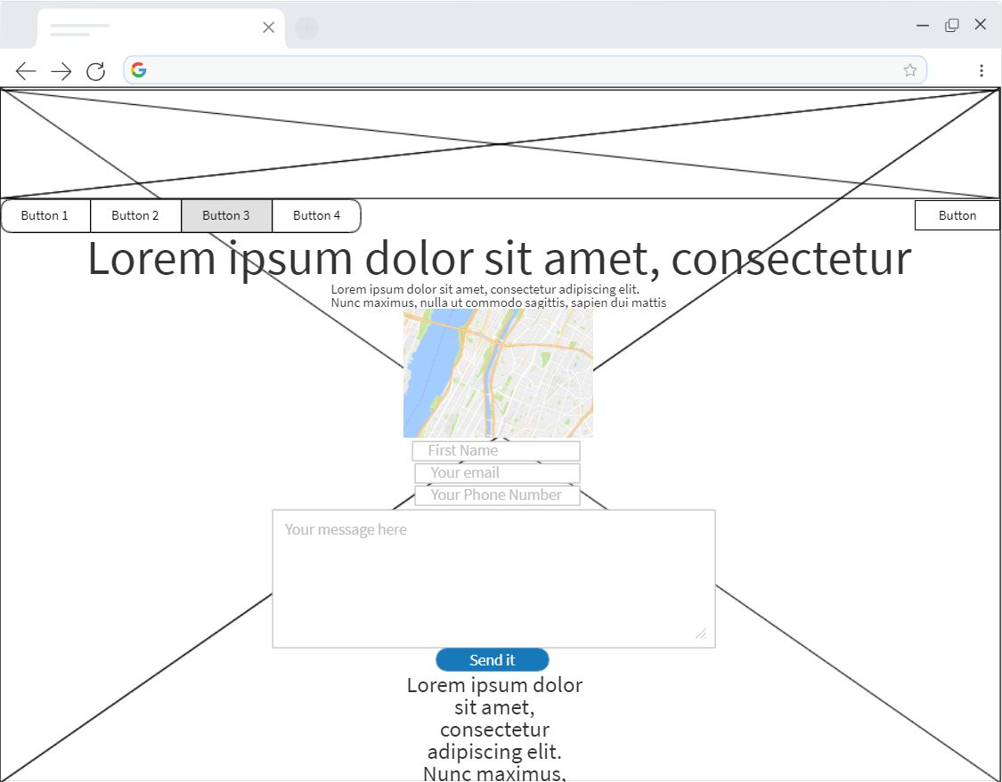

**Login page**

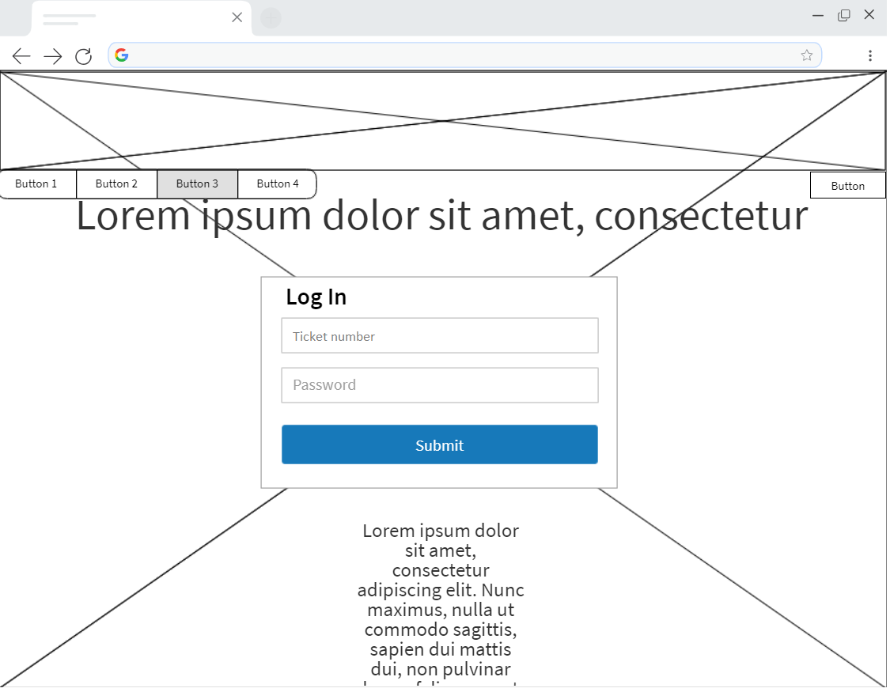

**Profile page**

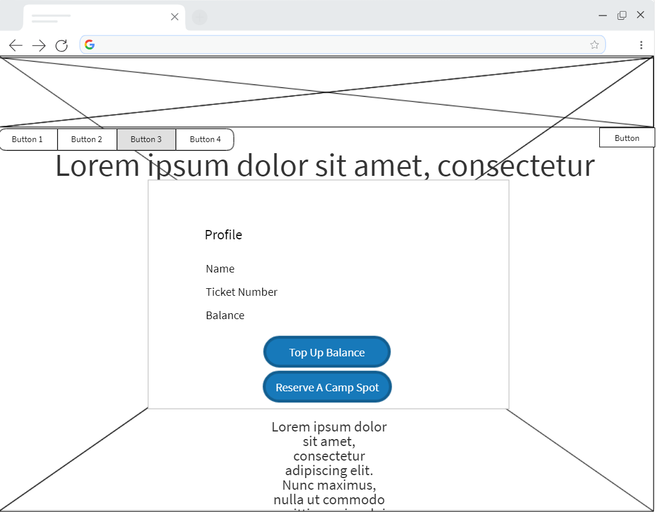

**Review page**

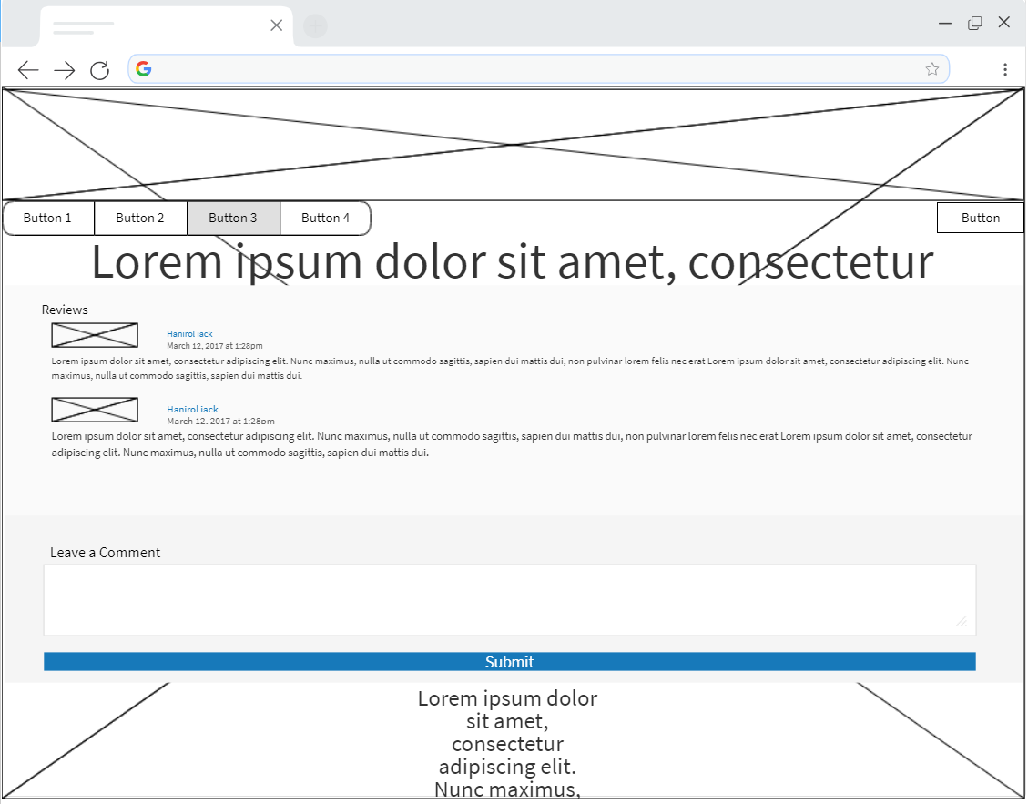

# Entity relationship diagram

